RENTAL AGREEMENT

This rental agreement, or the "Agreement," governs your client relationship with Stillwater Events Inc., also known as "We," "Us" or "SWINC." By accepting it electronically or otherwise, you, or the "Client," agree that you'll rent the equipment enumerated within the separate contract invoice that we provide you per that document's terms and this Agreement’s conditions, including:

BOOKING, PAYMENTS AND REFUNDS
You must pay a 25% non refundable deposit to confirm your booking and delivery date. Full payment is due within 7 days of the delivery time. If you cancel within 72 hour of the delivery time, a fee of 50% will be assessed. Cancellations within 24 hours of delivery result in a 100% fee being assessed.
We accept cash, check and all major credit cards (VISA, MASTERCARD, AMEX, DISCOVER).

RENTAL DELIVERY
. Delivery does not include set-up. Set-up and breakdown is subject to additional fee.
All product rates are for 1 day rental which includes delivery the day before and pick-up the day after event.
Delivery prices vary from the amount of the total invoice. Delivery is to a location not more than 25 feet from the loading/unloading area. Distances greater than 25 feet, stairs, above or below grade, soft ground or other obstacles can be negotiated ahead of time for an additional fee

Rental agreement page 1 of 3
AFTER RENTALS
At the end of the rental period, you must return all of the equipment in a state identical to how you originally got it. You must:
- Rinse silverware, glassware and dishware clean of debris,
- Ensure that linens are returned without stains, burns, candle wax or other marks and placed in the proper bagging, and
- Pack all other equipment, including attachments and parts, in the same crates and positions that they were in when you received them.
- Within no more than two business days following the pickup date, SWINC will furnish you with an invoice that details missing and damaged equipment. If you can’t locate missing equipment within 24 hours of receiving of such notice, you authorize us to automatically process a payment to the credit card that you provided.
- Equipment that is damaged will result in a charge to your credit card for its replacement value.

CLIENT RESPONSIBILITIES
Upon receiving a delivery, you or your duly authorized agent must verify it in person. You agree to sign off with a SWINC staff member acknowledging your receipt of the delivery and assumption of responsibility for the equipment.
If you receive equipment in a damaged or otherwise unusable state, you agree that you'll provide SWINC with written notification before your event commences. You also waive your right to seek refunds or any other credits for such rentals if you fail to notify SWINC of the problems in writing before the event. You acknowledge that SWINC won't accept order modifications or equipment exchange requests after our delivery representatives have vacated the drop-off location.

SWEPR RESPONSIBILITIES
You acknowledge that SWINC isn't responsible for breaches of the contract timeframe that are beyond our control, including traffic accidents, vehicular failures, regional security or any “acts of god”. The delivery schedule included in your contract is an approximation that doesn't constitute a guarantee.
The descriptions of the equipment that you rent may not perfectly match what you receive due to manufacturer variances, prior usage and other factors. SWINC may also substitute rental equipment for other functionally similar offerings at our sole discretion.

Rental agreement page 2 of 3

ACCEPTABLE RENTAL USAGE
You agree not to sublease, rent out or otherwise attempt to loan for remuneration any equipment that you rent from SWINC.

By accepting this Agreement, you consent to its terms and conditions in full, and you acknowledge that they pertain to all SWINC invoices regardless whether such documents include their own terms.

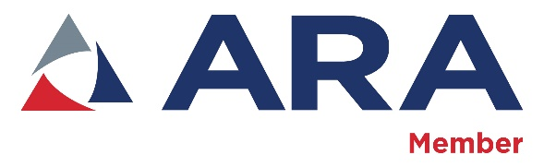

Rental agreement page 3 of 3

